**12. Demonstrate virtualization by Installing Type-2 Hypervisor in your device, create and configure VM image with a Host Operating system (Either Windows/Linux), using VMware workstation.**

STEP 1 :click on create resource and type for vm

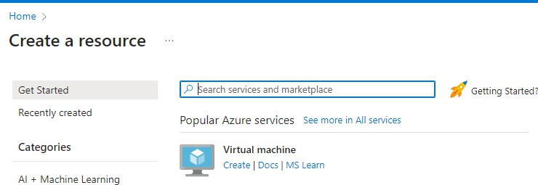

step 2 : able to see all 8 tabs avaible in virtual machine

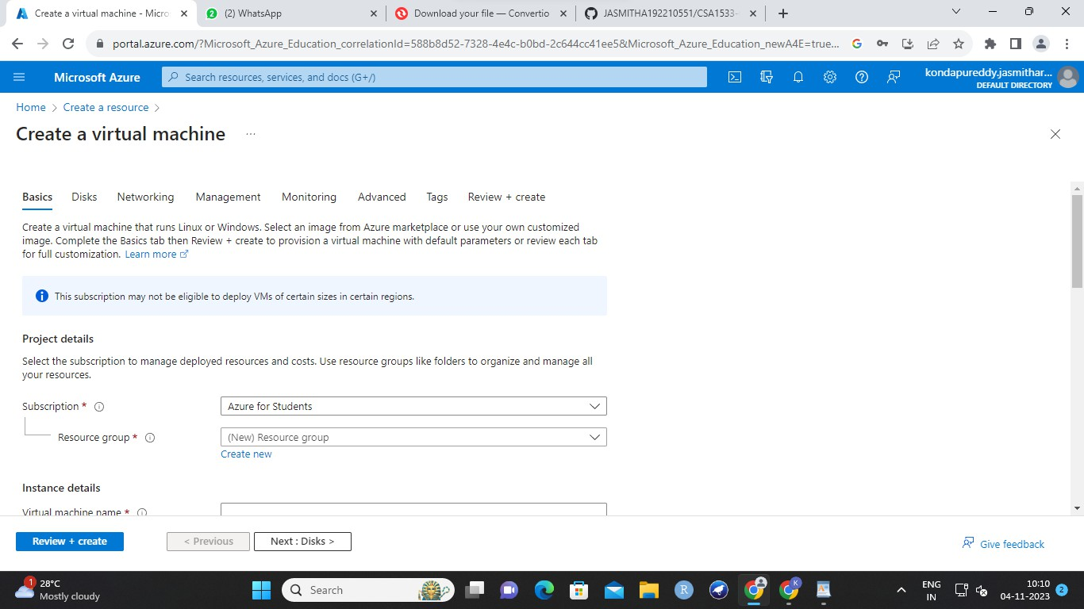

step 3 :

enter any name and write azure name

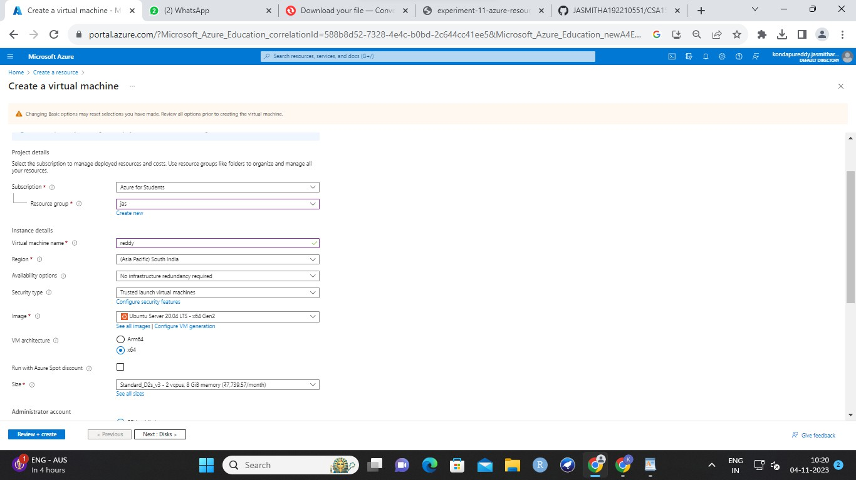

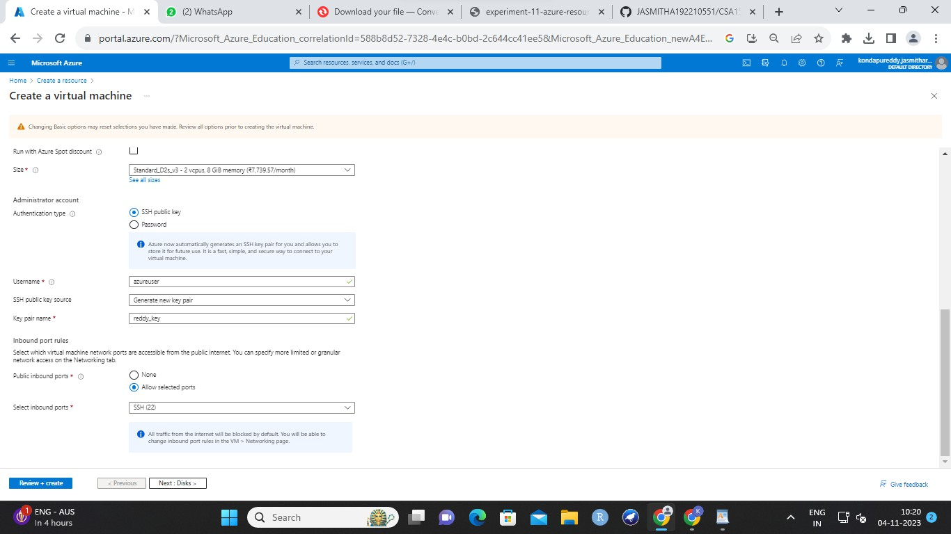

step 4 : enter data in disk

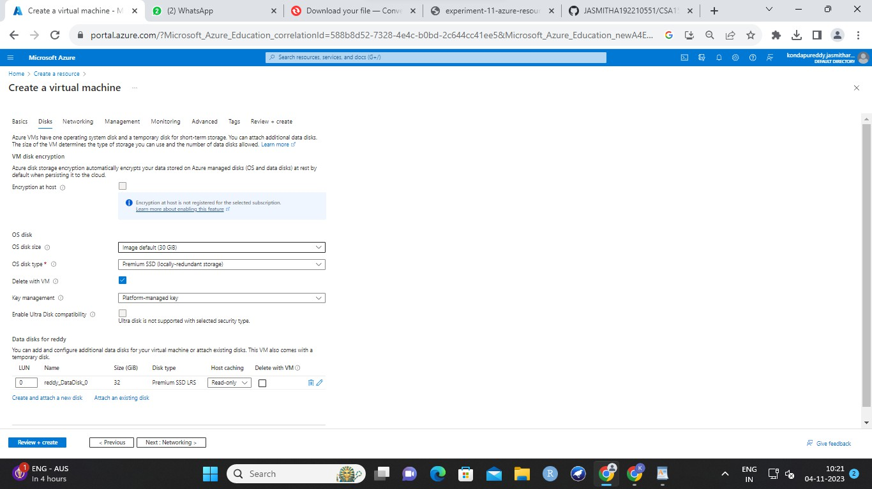

step 5 : go for networking

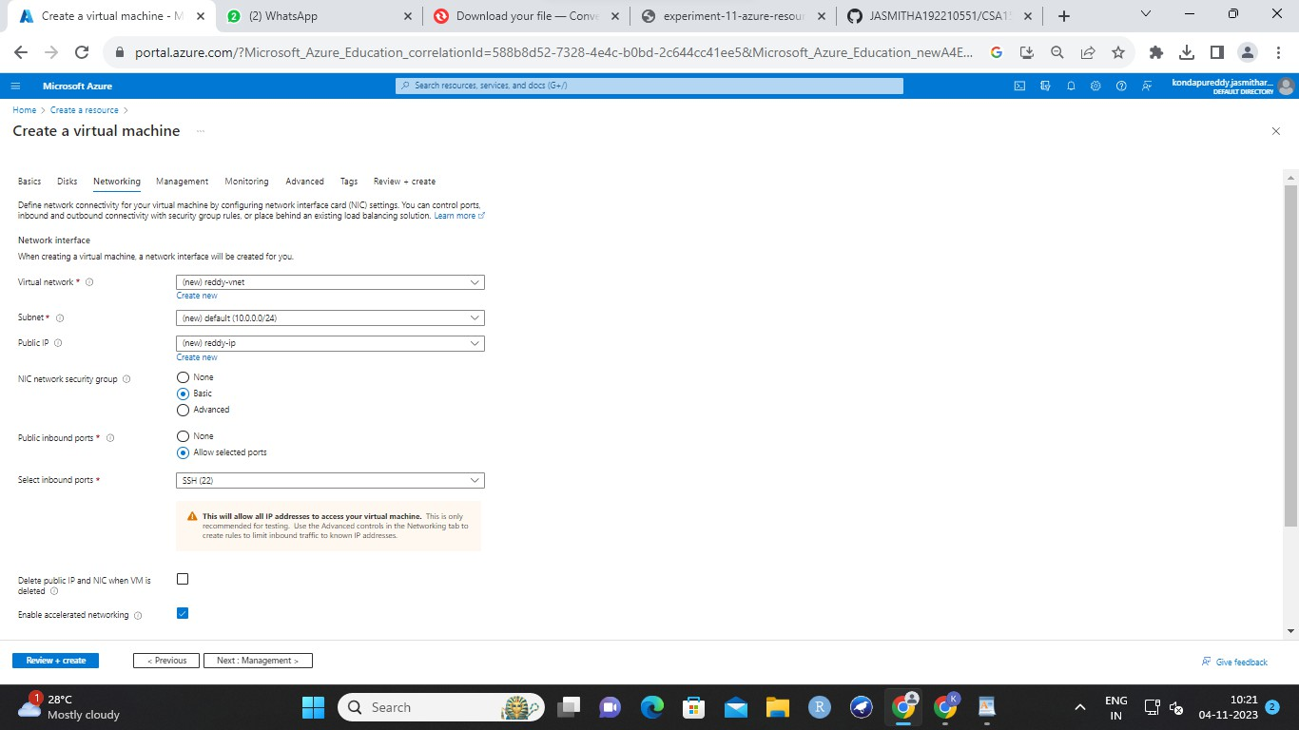

step 6 : then management and default

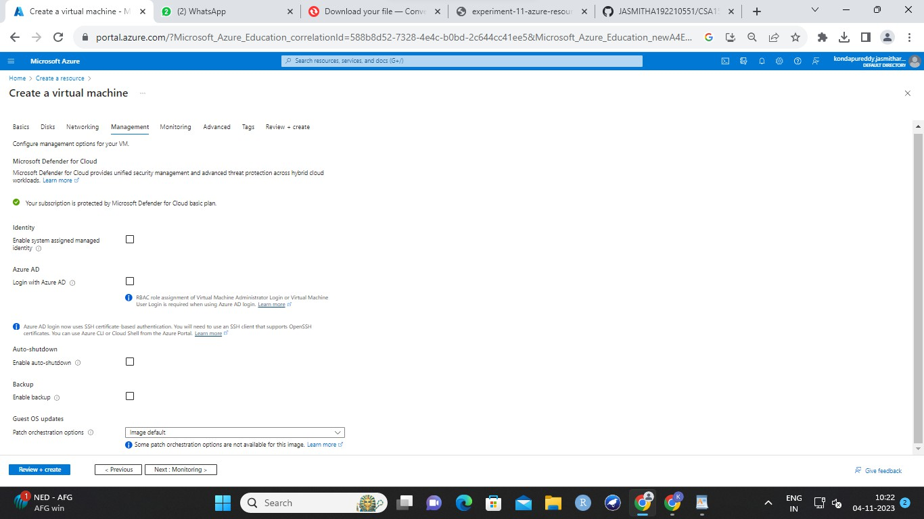

step 7 : deafault monitoring

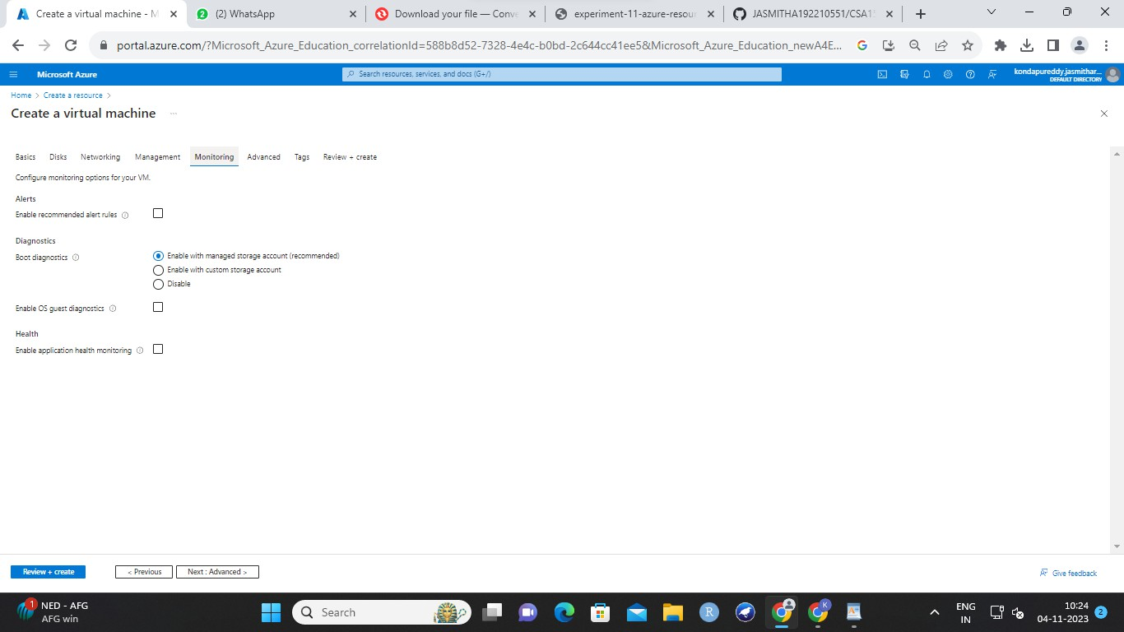

step 8 : default advanced

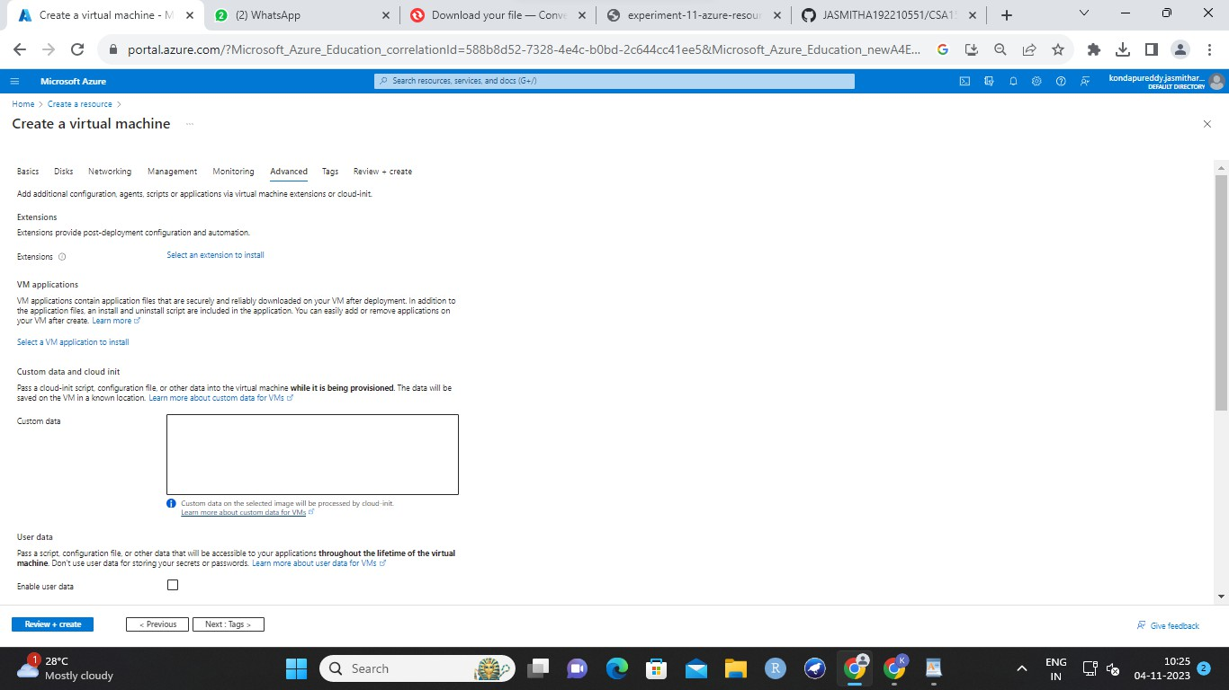

step 9 : enter data in tags

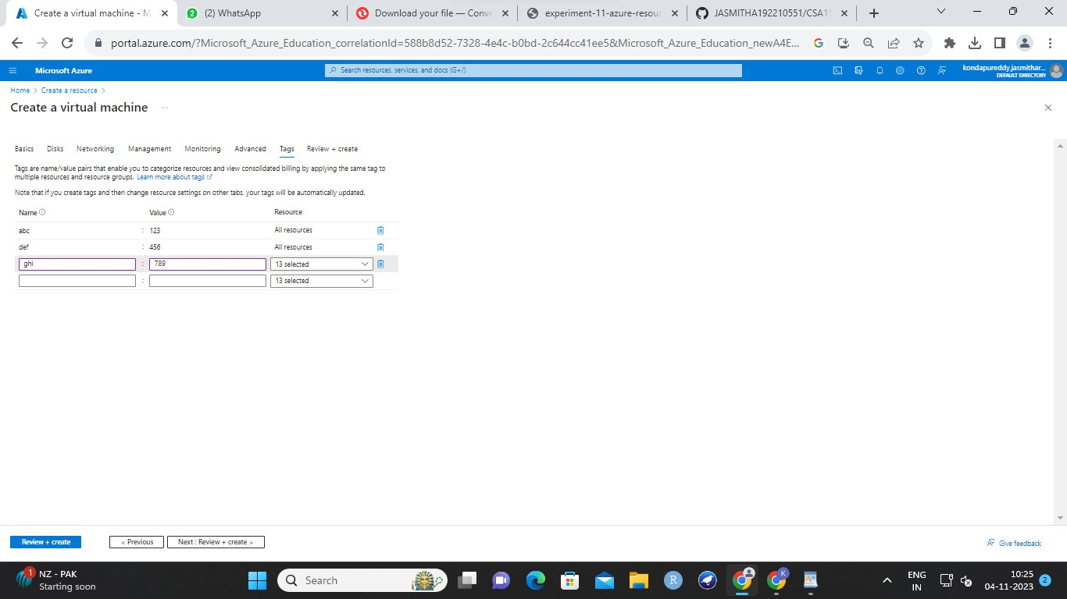

step 10 : review

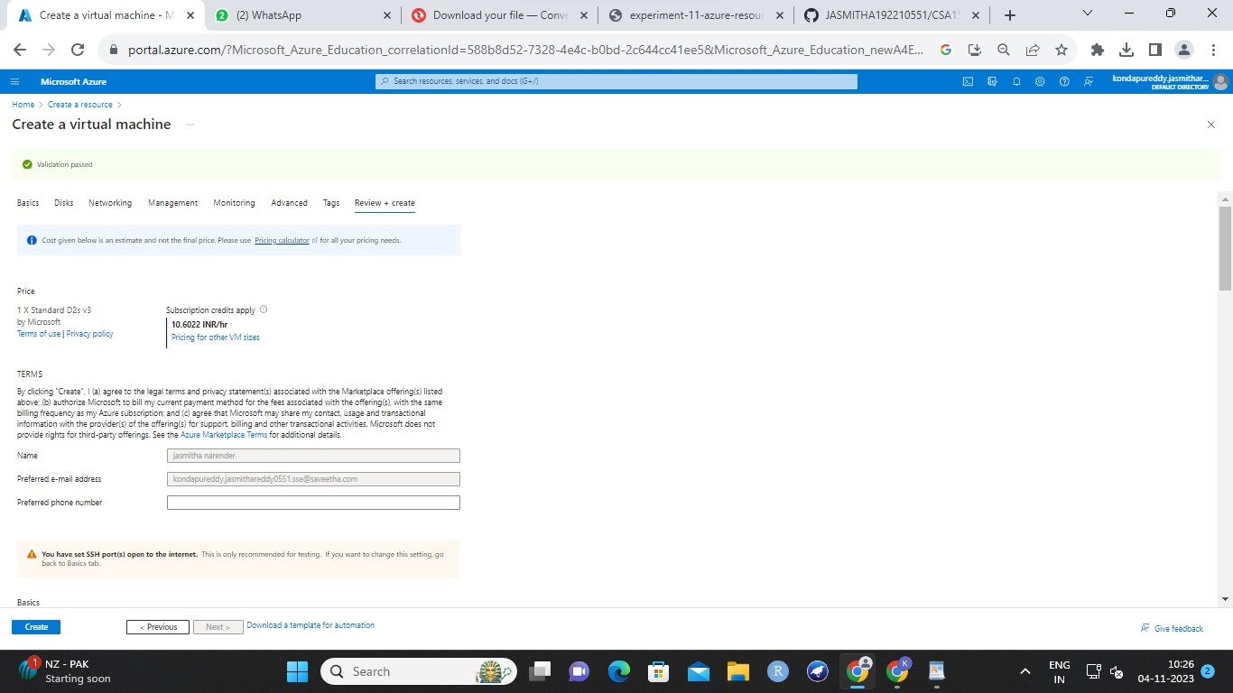

step 11 : result

